When to use Extension Methods in C#?

You need to use an extension method if any of the following conditions are true:

* You need a method on an existing type and you are not the owner of the source code of that type.
* You need a method on an existing type, you do own the source code of that type but that type is an interface.
* You need a method on an existing type, you do own the source code and that type is not an interface but adding the method creates undesired coupling.

How to Implement Extension Methods in C#?

Let us understand this with an example. Our requirement is that we want to add a method in the built-in string class, let’s call this method **GetWordCount()** which will count the word present in a string separated by a space.

For example, if the string is “Welcome to Dotnet Tutorials”, then it should return the word count as 4. The most important point is that we need to call this method on the String object as shown below.

**int wordCount = sentence.GetWordCount();**

Note: We cannot define the **GetWordCount()** method directly in the string class as we are not the owner of the string class. The string class belongs to the System namespace which is owned by the .NET framework. So, the alternative solution to achieve this is to write a wrapper class as shown below.

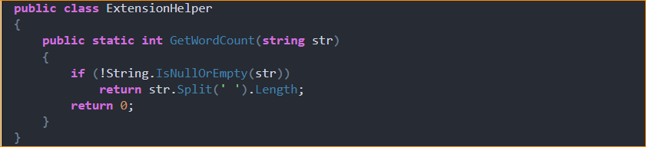

The above ExtensionHelper Wrapper class works fine, but the problem is, here we cannot call the GetWordCount() method using the string object as shown below.

**int wordCount = sentence.GetWordCount();**

Instead, we need to call the GetWordCount() method as shown below.

**int wordCount = ExtensionHelper.GetWordCount(sentence);**

1. First, we need to make the ExtensionHelper class a static class.
2. Second, the type the method extends (i.e. string) should be passed as the first parameter preceding the “this” keyword to the GetWordCount() method.

With the above two changes in place, now the GetWordCount() method becomes an extension method and hence we can call the GetWordCount() method in the same way as we call an instance method of a class. The complete example code is given below.

